**Devansh Shah & Dhruv Kothari**

**1914078 & 1914015**

**Exp 1**  
  
  
Website used: <https://passedonwisdom.herokuapp.com/>

**Problem Definition**

Passed On Wisdom Aim to Provide the Younger Generations a Marketplace to Buy All the Necessary Items for a College Starter Pack at a Cheaper Price. Passed On Wisdom is a Platform where senior students can post ads of books or other necessary engineering items like calculator, toolkit, lab coat, boiler suit which has been used or is unused. They can basically sell this items by filling a form and uploading images of the item if necessary. The item, if it is a book can be verified by the admin and the advertisement will be posted on the website for anyone to view. Similarly junior students can buy the item at cheaper rates, and can then again pass it to their juniors.

Hence it is a Platform for All to Post Ads for and Purchase these verified items at a cheaper price as well as Buy and Sell Reference Books.

|  |  |  |
| --- | --- | --- |
| **Sr No.** | **Functional Requirements** | **Test Cases** |
| 1 | Admin can login into the system | Admin should be able to login and perform the further activities |
| 2 | Admin can change the status of a book | Books status can be changed to verified or rejected |
| 3 | Students can login into the system | Students should be able to login and perform the further activities |
| 4 | Students can search for any books with or without login | Searched book should be displayed on the screen |
| 5 | Student can upload any book | Student uploaded book visible in admin panel |
| 6 | Rejected books by admin does not appear to anyone | Student gets a rejection message and book deleted from database |
| 7 | Students can sell other products | Addition of the products into the database |
| 8 | Students can buy any book or any other products | Status of book/product changed and confirmation mail sent to the seller |
| 9 | Students can edit their year of study and phone number | Students can edit their year of study and phone number |
| 10 | Student must not be able to send book if not authenticated | Student redirect to login page if not authenticated |

**Testing Tools**

**Selenium**

Originally developed by Jason Huggins in 2004, Selenium is a framework for testing web applications and automating web browsers. Unlike Django's testing framework, Selenium actually automates user interaction on a given website as if a real user is performing the actions. Of course, this means Selenium can be used for reasons other than testing, such as automating an e-commerce's checkout to create a sneaker bot.

**Unit Test**

Testing a Web application is a complex task, because a Web application is made of several layers of logic – from HTTP-level request handling, to form validation and processing, to template rendering. With Django’s test-execution framework and assorted utilities, you can simulate requests, insert test data, inspect your application’s output and generally verify your code is doing what it should be doing. The preferred way to write tests in Django is using the [**unittest**](https://docs.python.org/3/library/unittest.html#module-unittest) module built-in to the Python standard library. This is covered in detail in the [Writing and running tests](https://docs.djangoproject.com/en/3.2/topics/testing/overview/) document.

**Apache Bench**

Apache Bench is used as a benchmarking tool to let you know how many requests your Apache web server can handle. However, it can be used to test any other web server too. In one terminal, we're going to be running the Django web server. In another terminal, we're going to be running AB, which is the command to run Apache Bench. We use the N option, which is the number of requests to make. And then we're going to be hitting the Django web server at the index

Selenium:

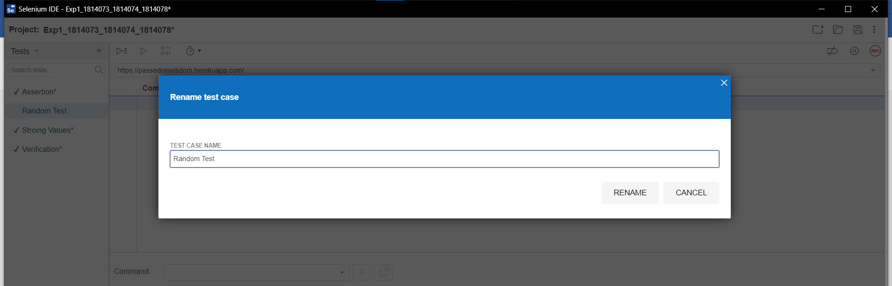

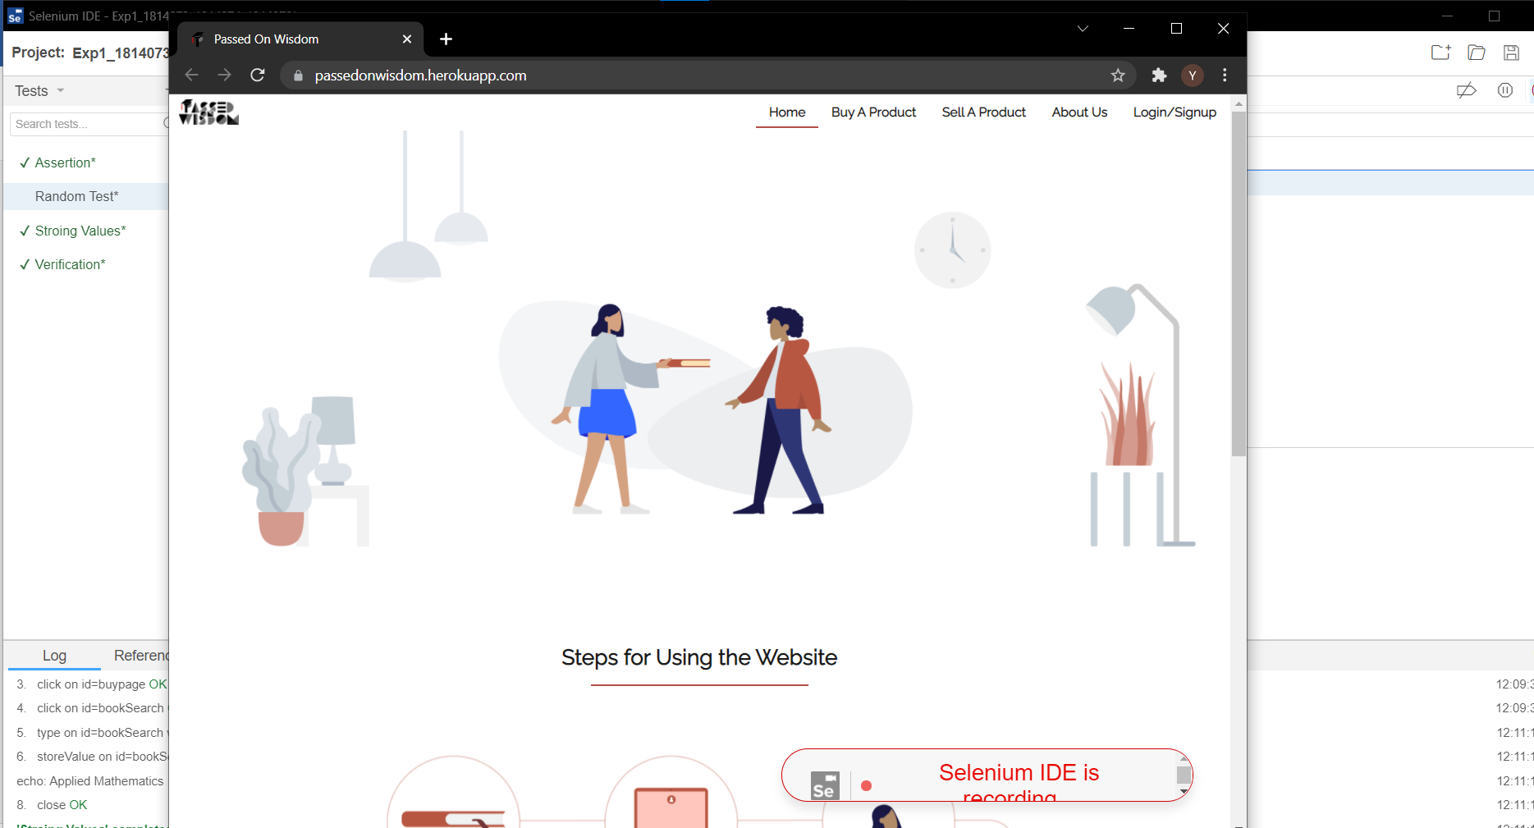

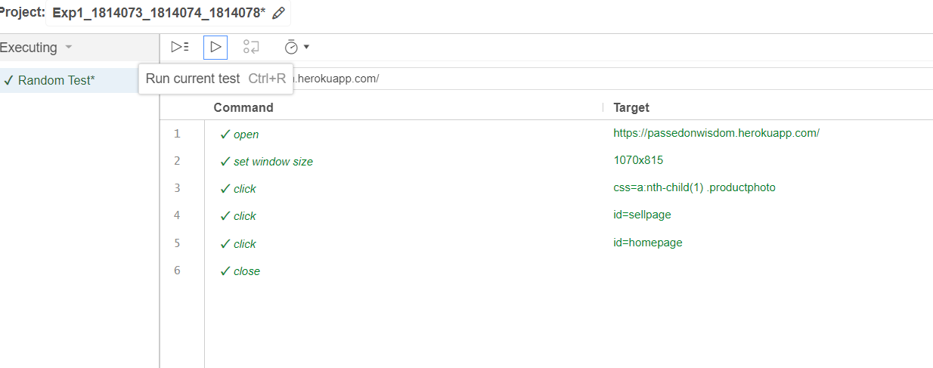

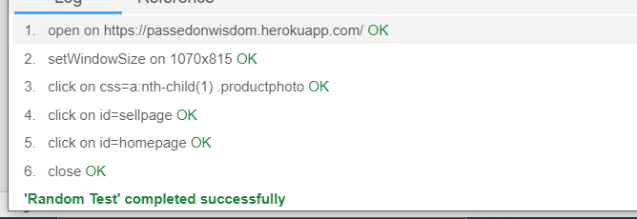

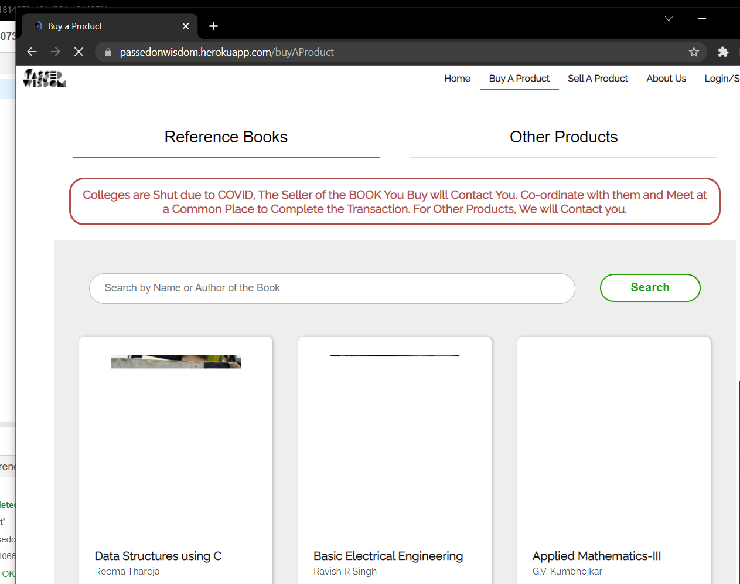

verification

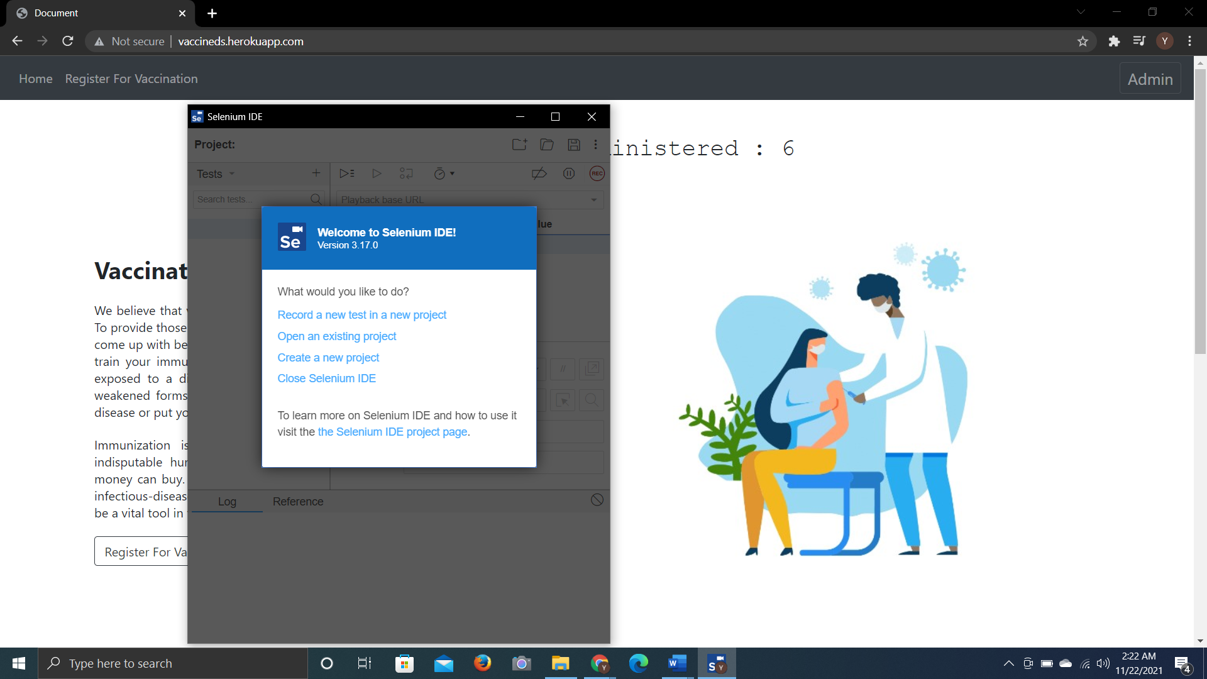

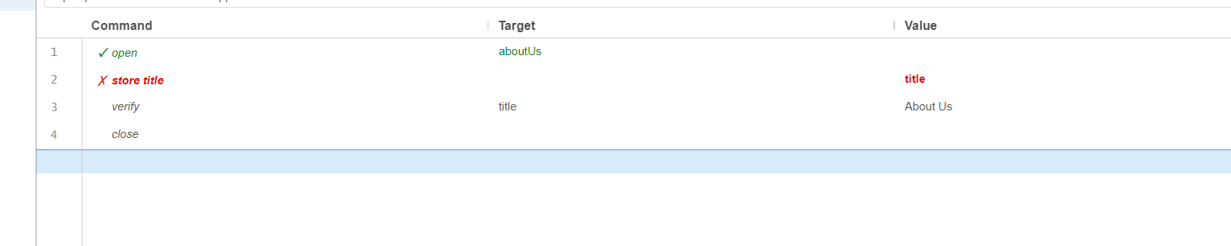



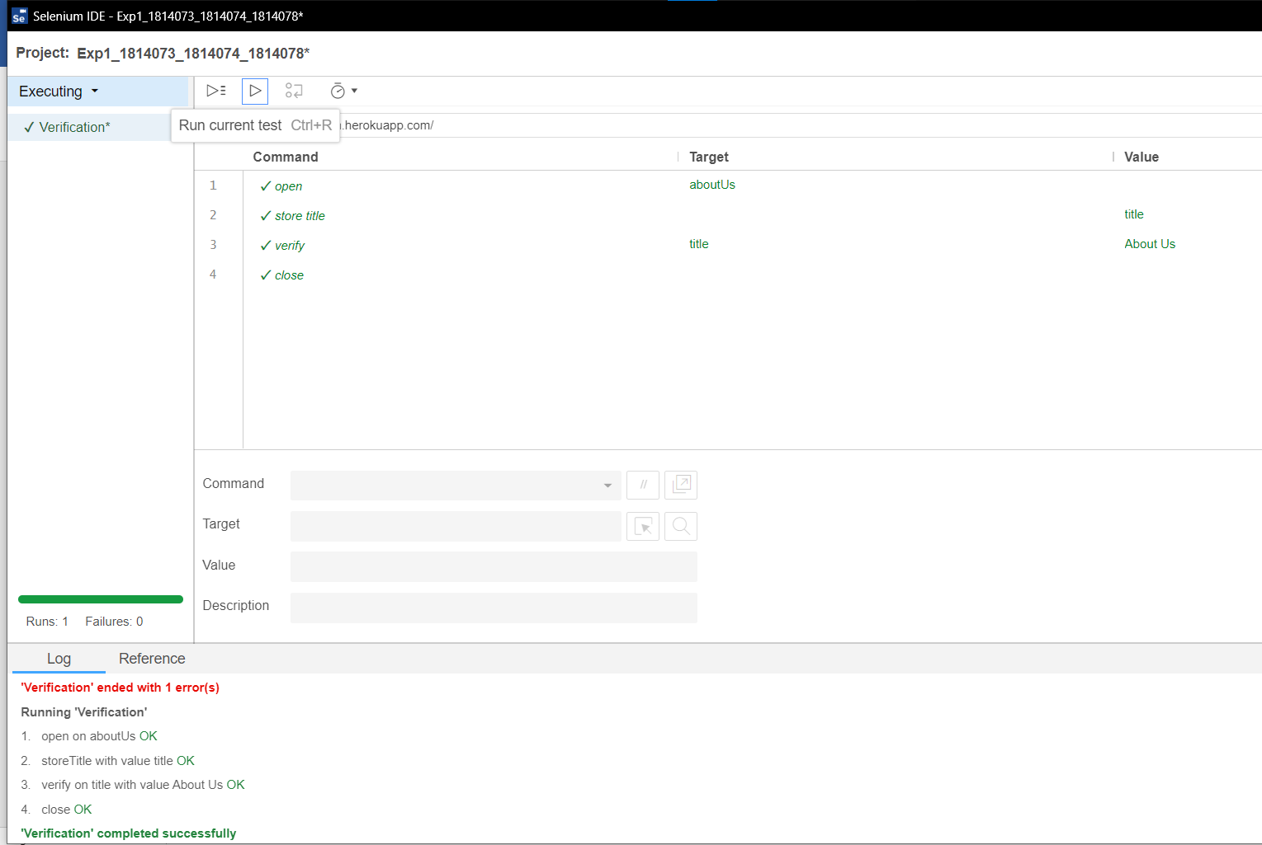

Assertion

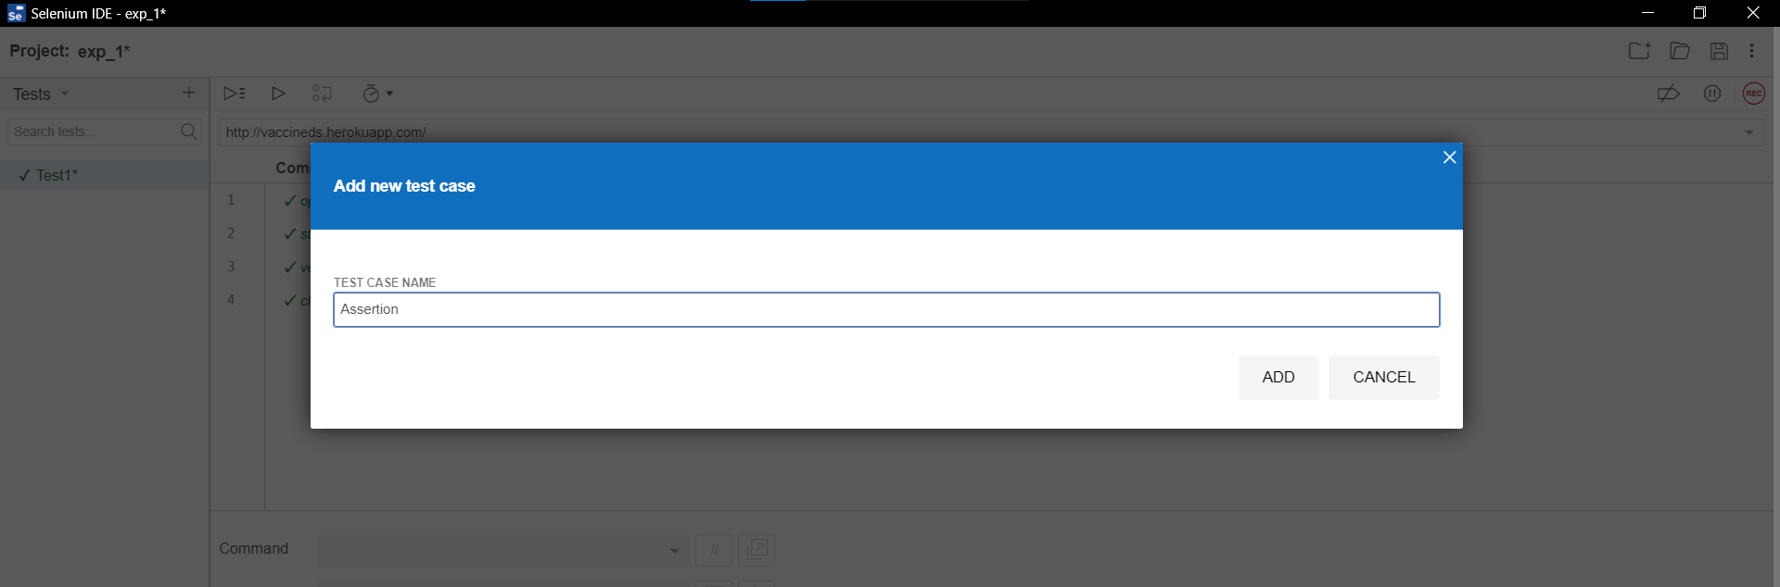

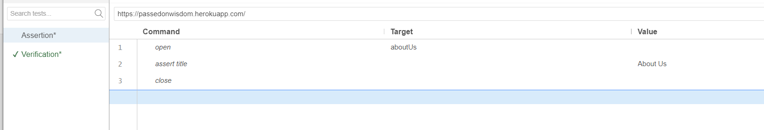

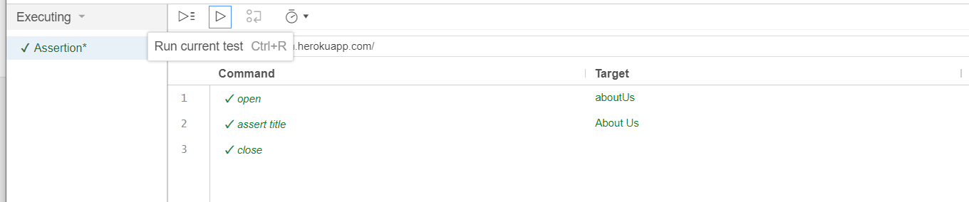

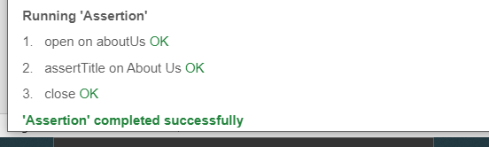

Storing values

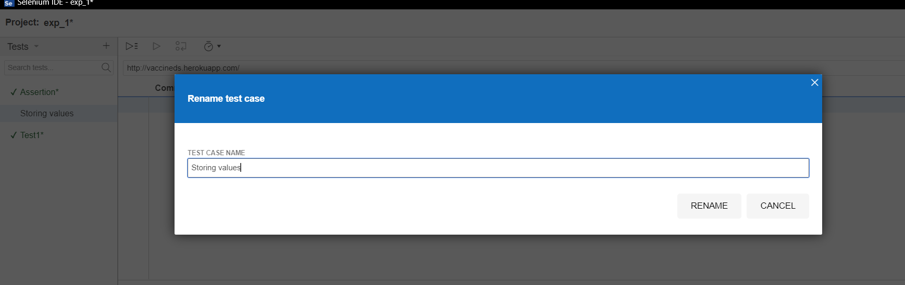

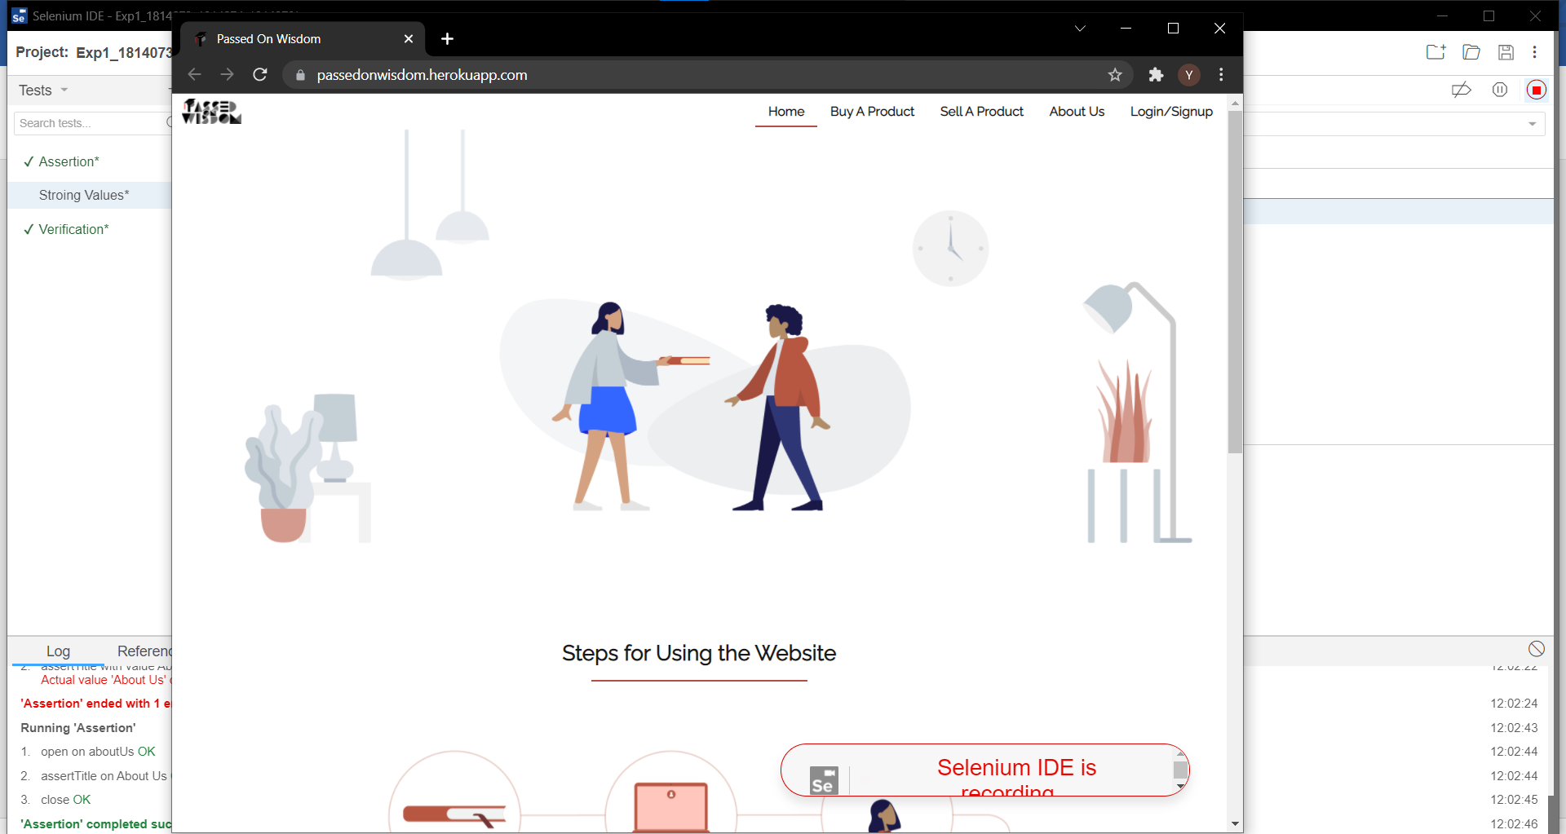

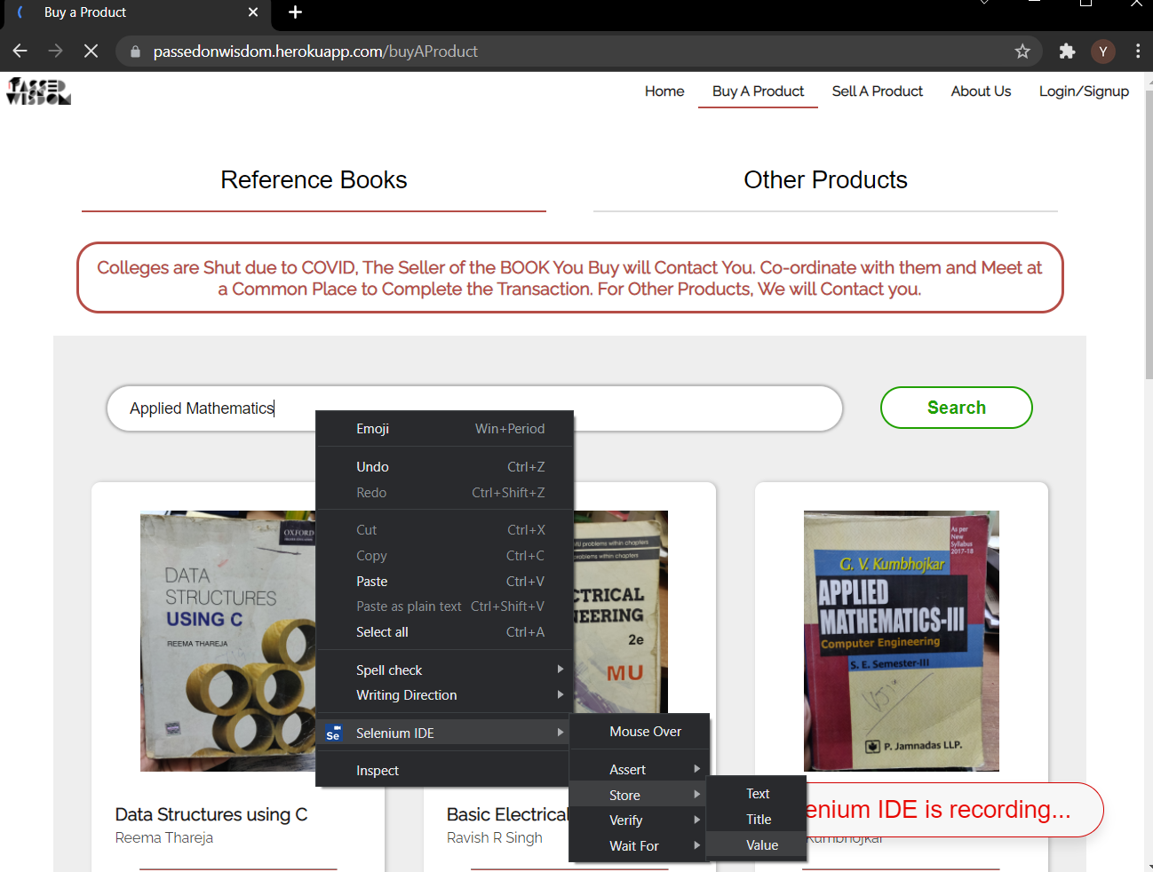

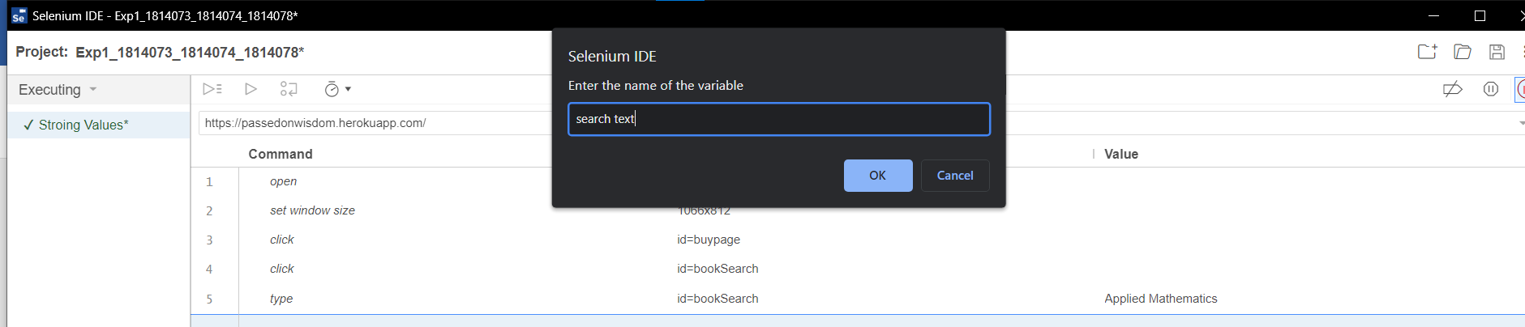

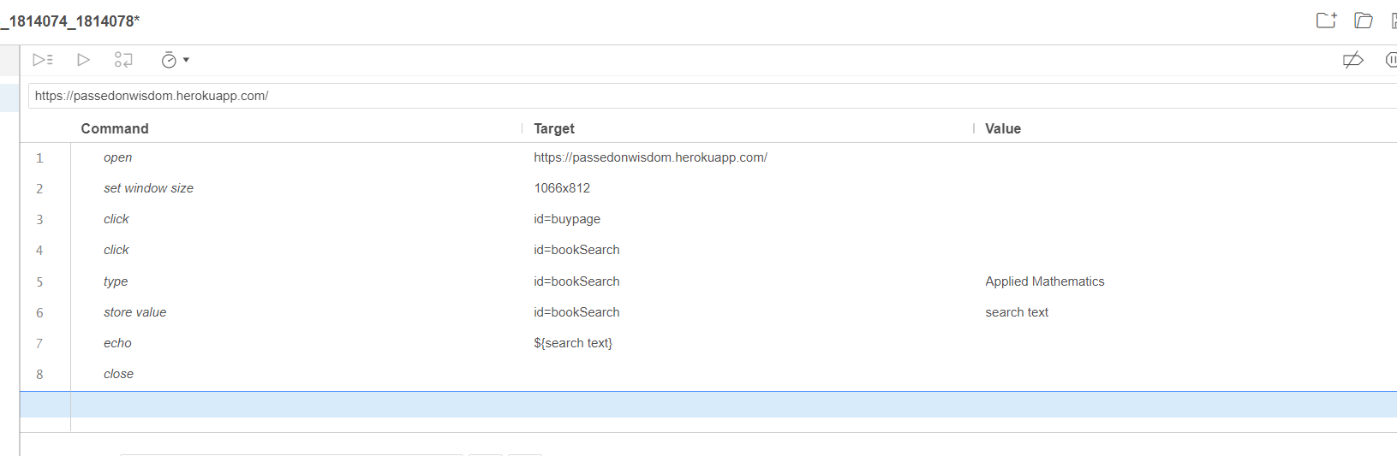

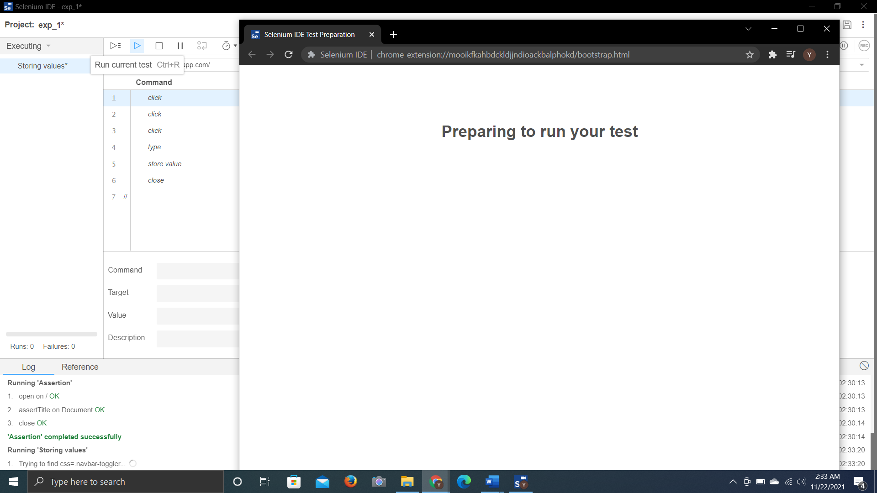

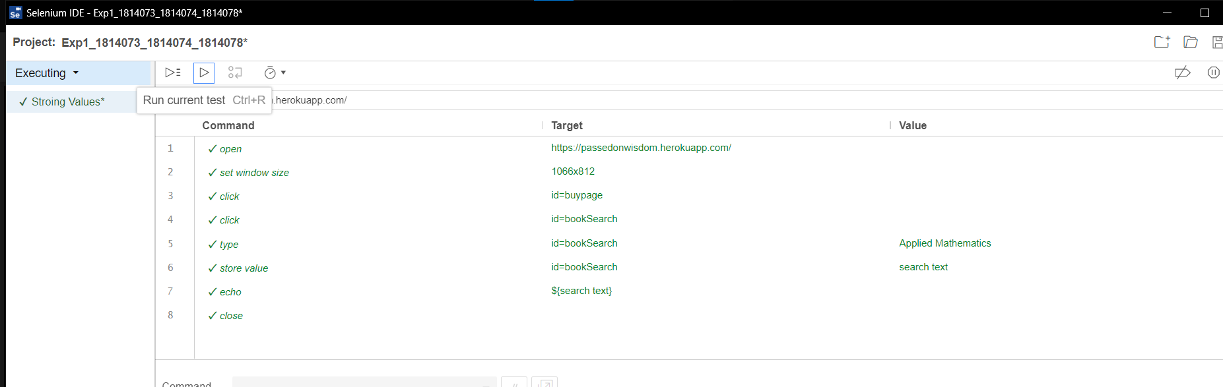

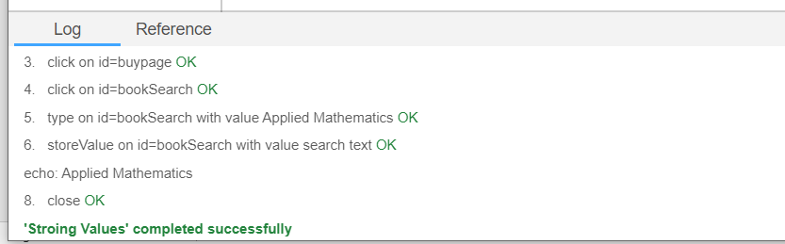

LIGHTHOUSE:

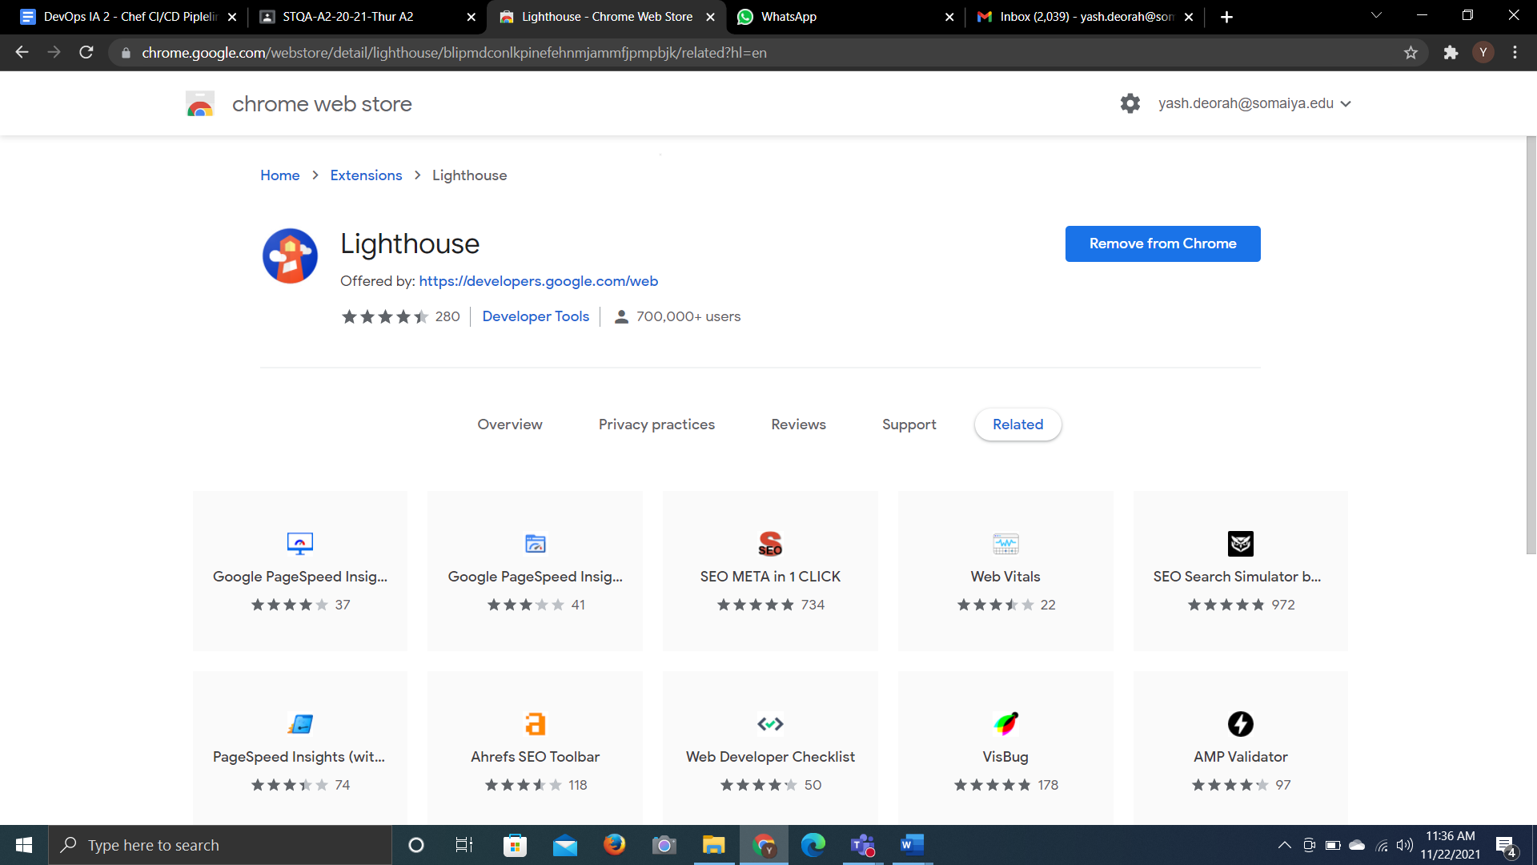

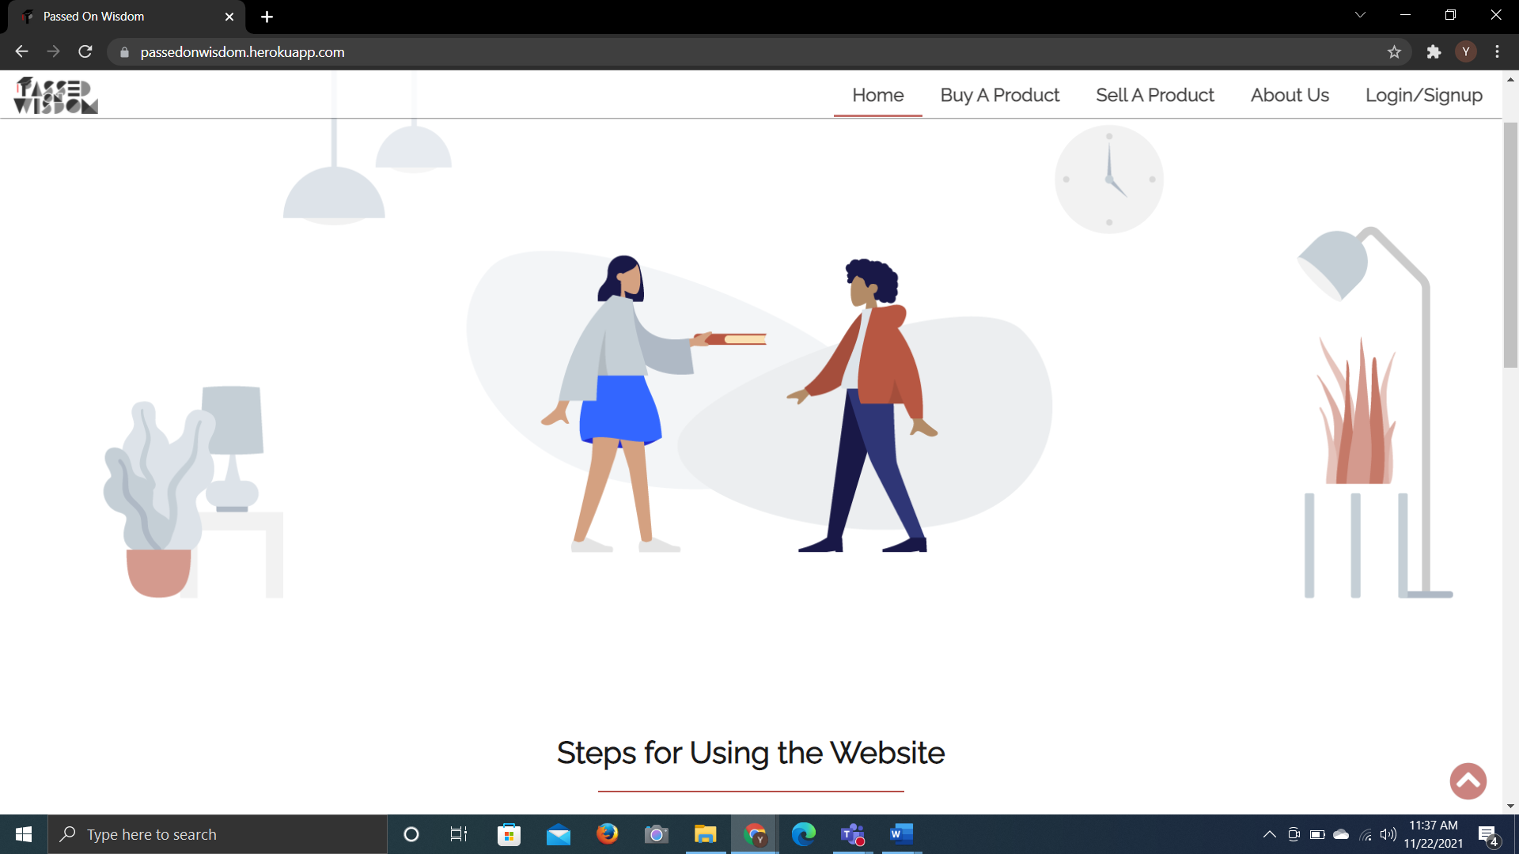

Generating report using lighthouse

